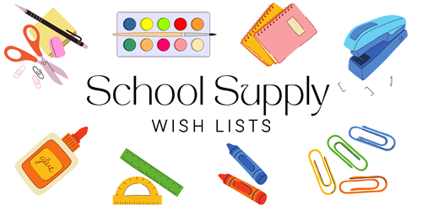

**2nd GRADE**

**24/25**

**PERSONAL ITEMS – LABEL WITH CHILD’S NAME)**

2 LANYARDS WITH CLEAR BADGE HOLDER (HEAVY DUTY)

1 ASSEMBLED SOFT PENCIL POUCH: with Sharpened pencils, crayons, scissors, glue stick and 2 highlighters

1 DECORATIVE PLASTIC POCKET FOLDER

1 WHITE 3 RING 1” BINDER WITH CLEAR COVER INSERT

1 PAIR OVER THE HEAD HEADPHONES (LAPTOP COMPATIBLE)

**CLASSROOM ITEMS: DO NOT LABEL**

6 MEAD MARBLE COMPOSITION NOTEBOOKS (100ct)

3 LARGE GLUE STICKS

2 REAMS COPY PAPER

3 PACKS BLACK EXPO LOW ODOR CHISEL DRY ERASE MARKERS

48 #2 YELLOW TICONDEROGA PENCILS (SHARPENED)

2 SHARPIE BLACK MARKERS (NOT ULTRA FINE TIP)

1 PACKAGE OF BABY WIPES

1 BOX OF 50 PAGE PROTECTORS

3 PLASTIC POCKET 3 RING PRONG FOLDERS (1 RED, 1 BLUE & 1 GREEN)

**GIRLS ONLY:**

1 BOX OF SANDWICH SIZE ZIPLOC BAGS

**BOYS ONLY:**

1 BOX GALLON SIZE ZIPLOC BAGS